Tweet sentiment analysis

Introduction
This objective of this project was tasked with the development of a text classification system that can accurately tell the sentiment of tweets regarding the stock market crash in 2022. The data source is from online platform Kaggle. The data file contains two columns, the first is the content of tweet, the second column is the text sentiment which is the target variable that going to predict in this project.

Data Processing
Before building model, we cleaned the text so that it can be ready for analysis. First, removing the unnecessary parts from the text including URL, hashtag and mention etc..
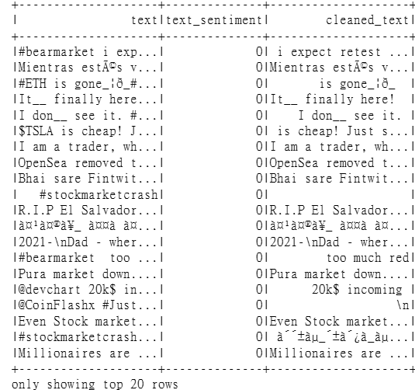
Then, building pipeline tokenizes the cleaned text into words and removes stopwords. The remaining tokens are converted into term-frequency vectors using hashing, then reweighted by inverse document frequency to obtain TF‑IDF features, which helps reduce overfitting risk.

Building a baseline model
When thinking about a good model, we finally decided on Logistic Regression for the data analytic model and TFIDF for word embeddings as baseline model. We have several reasons for doing this from both the LR side and the TFIDF side.
Logistic regression is a very straightforward model that provides very simple, interpretable results. This makes it easy for us to understand the reasoning behind the model and from there build it up to more complex models. Moreover, even though Logistic Regression is a simple model, it is very efficient when it comes to classification problems and in our case, text sentiment analysis. Likewise, TFIDF also provides a simple and efficient way of representing text and in our task, using TFIDF is a great way to quantify the importance of a word. The accuracy of baseline model:
Accuracy of Baseline Model: 0.5465

Implementation of different models and word embeddings
Then choosing Random Forest, Naïve Bayes and Decision Tree compare with our baseline model. Random Forest can capture complex patterns, and it is robust when working with high dimensional data as the word embeddings from TFIDF. Naïve Bayes performs well on sparse datasets like ours due to the high dimensionality from our data and it is a popular choice for classification tasks like our project. Lastly decision tree can help us identify key feature in texts that can help us determine sentiment. After running all of these models with TFIDF we got the following result:
Random Forest (TF-IDF)
Random Forest (TF-IDF) - Accuracy: 0.3855

Naive Bayes (TF-IDF)
Naive Bayes (TF-IDF) - Accuracy: 0.5193

Decision Tree (TF-IDF)
Decision Tree (TF-IDF) - Accuracy: 0.4422

For Word Embeddings, we chose two different models including Word2Vec and GloVe. Word2Vec is able to capture contextual relationships, meaning it defines the meaning of words based on their context. For our task, many of the words were used in all negative, positive and neutral context so we were expecting a slight increase in accuracy for our baseline model + Word2Vec. GloVe was from the start a very promising model since it can combine local word context and global statistical information from the corpus. Though we originally intended to use the pretrained GloVe model on tweet data, we found that it was not supported by the official SparkNLP documentation, and it would be harder to implement, thus we ended up using glove_100d. Even though we continued the project with this modification, LR + GloVe model outperformed the other models significantly.
Word2Vec + LR Accuracy: 0.4785
GloVe + LR Accuracy: 0.6077

Improving our baseline model
To improve, we applied two strategies: Hyperparameter Tuning and Ensemble Learning.
Hyperparameter Tuning with Cross-Validation
a) Random Forest controls complexity via tree number and depth. We tuned it to balance bias-variance trade-off. The result accuracy is 54%. This indicates the TF-IDF features are linearly separable, and adding more trees/depth cannot capture more signal. Random Forest struggles with high-dimensional sparse text data.
Accuracy with best RF: 0.5420
b) Naive Bayes smoothing handles zero-probability words in tweets. We tuned it to capture those words. The result accuracy is 54%. This shows NB is sensitive to noisy short texts. Tweet slang, emojis, and imbalanced classes break its conditional independence assumption.
Accuracy with best RF: 0.5420
c) Decision Tree also controls complexity via tree number and depth. We deeper trees to capture more rules. The result accuracy is 51%. Worse than RF/NB. Decision Tree severely overfits on 100,000 TF-IDF features, memorizing training tweets and failing to generalize.
Accuracy with best DT: 0.5102
All three models between approximately 51% and 54%, proving single models are insufficient. Therefore, moving to ensemble models.
Improving the model by using ensemble models
a) In the Voting method, we try to combine the predictions from 3 models after hyper tuning. From 3 voting strategies (Hard, Soft, Weight) we choose a hard voting method since it is easier to implement. Hard Voting ‘s process is like, if Model 1 predicts it is 0, Model 2 predicts 1, Model 3 predicts 0, then the final prediction will be 0. The accuracy for this ensemble model has improved from 54.65% to 70.74% over baseline model.
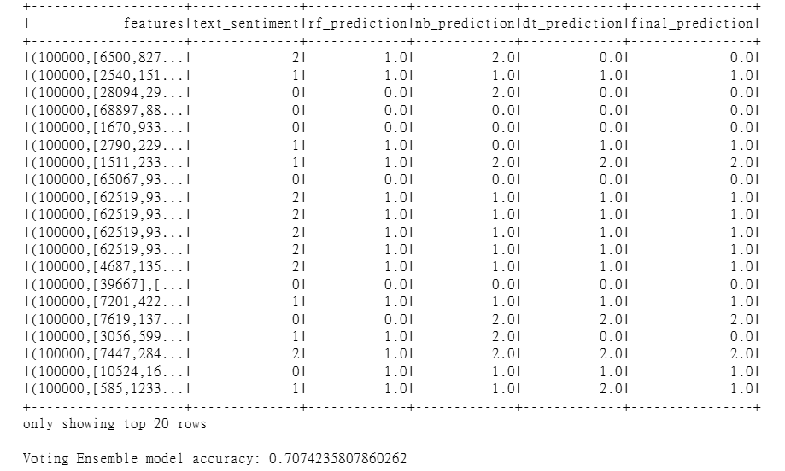
b) In Stacking Method, we have to train a meta-learner on the predictions of the base models. We use the predictions from baseline models as inputs for the meta-learner model. The model learns how to weigh the contributions of each base learner to make the final prediction. The accuracy of the model is 62.7%.
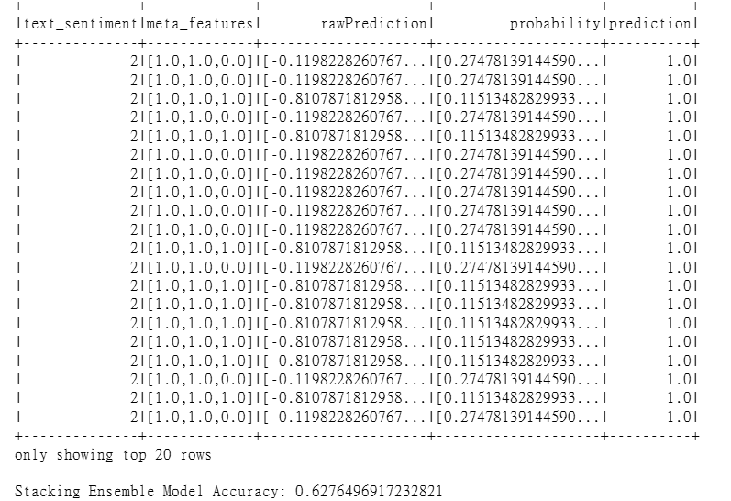

Data Visualization
We tried different kinds of graphs for data visualization, eg word cloud, stacked bar chart, word distribution and plot graph for analysing our data. We had a total of 1692 data, and we could see the data are evenly distributed while positive comments have the highest frequency. We also could see the text-sentiment is having a mean of 0.95 with the standard deviation of 0.79.
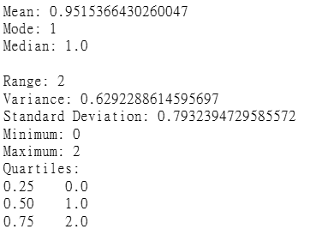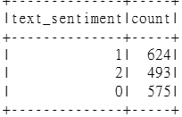
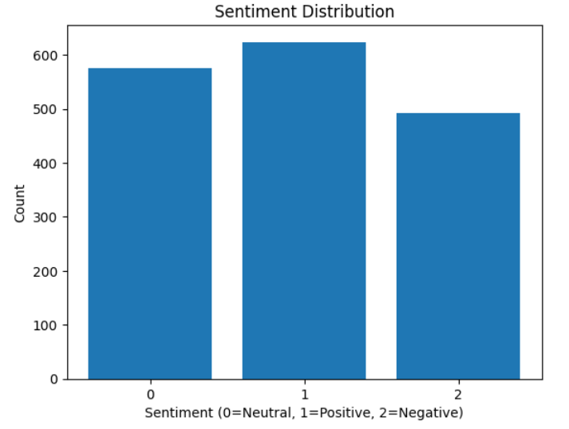
We also tried Word Cloud based on text-sentiments (0, 1, 2) and also based on the word form (noun, adjective, verb). We found out neutral comments having a unique word of ‘think, dip’. While for positive and negative comments, they are having unique word of ‘good’ and ‘crash’ respectively. Moreover, from Word Cloud shows the most frequent words used based on their word form.
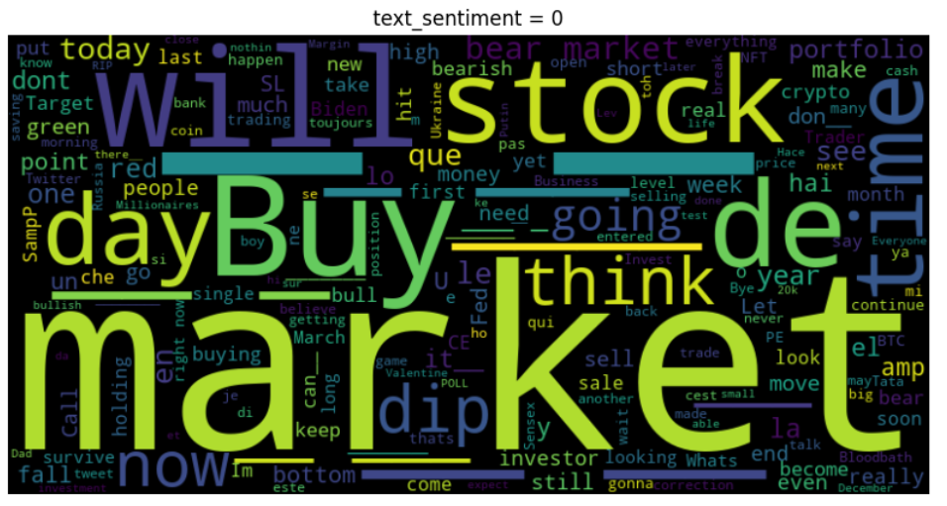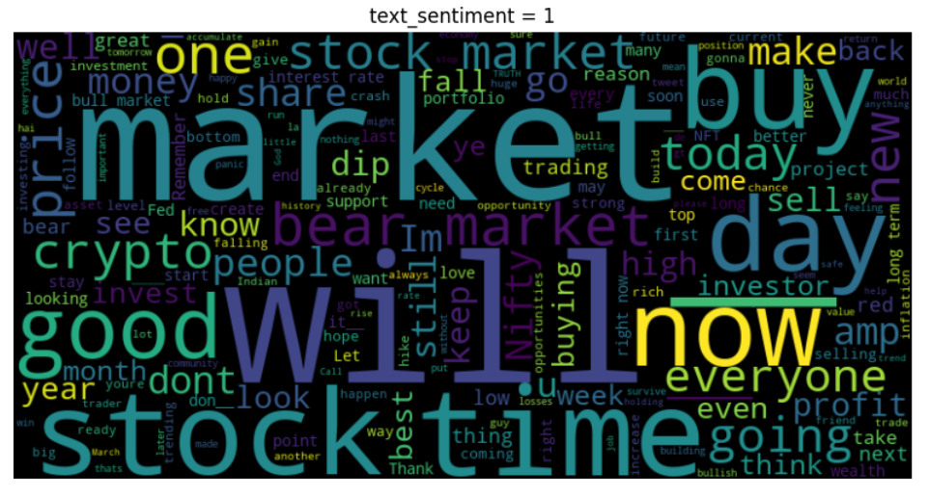
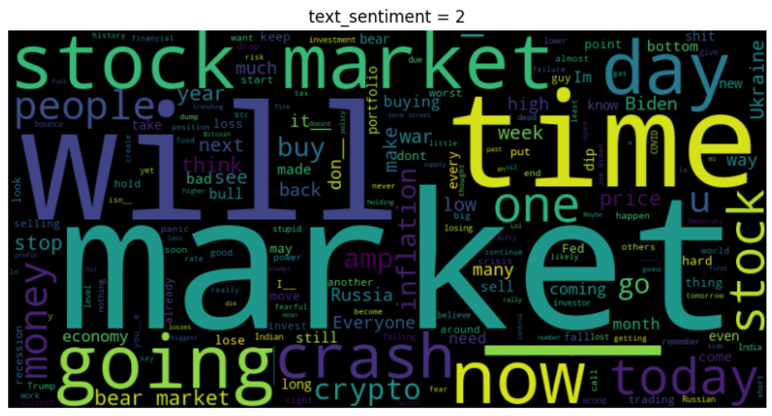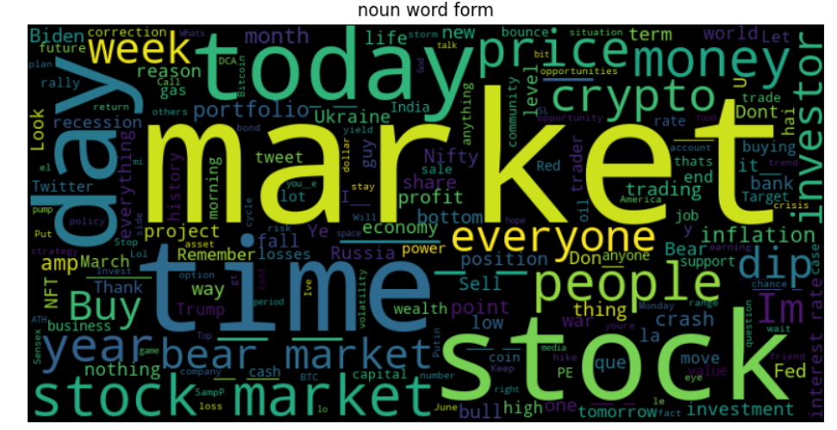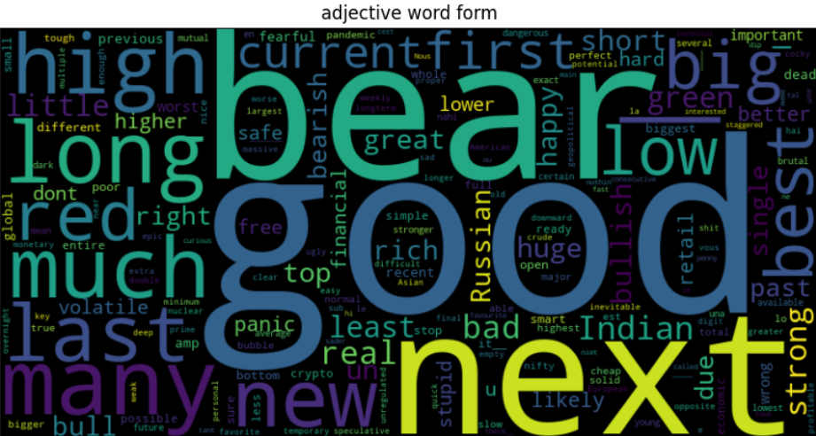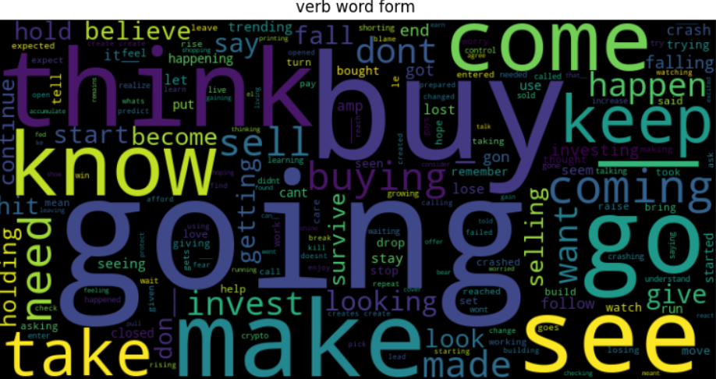
Stacked bar chart was implemented to show the most frequent hashtags used with the frequency of text-sentiment. Showing the hashtags are used evenly for all comments. Moreover, we found top 30 word frequency, top 30 bigram and top 30 Trigram frequency. Showing ‘the’ and ‘in the’ are used the most among all words.
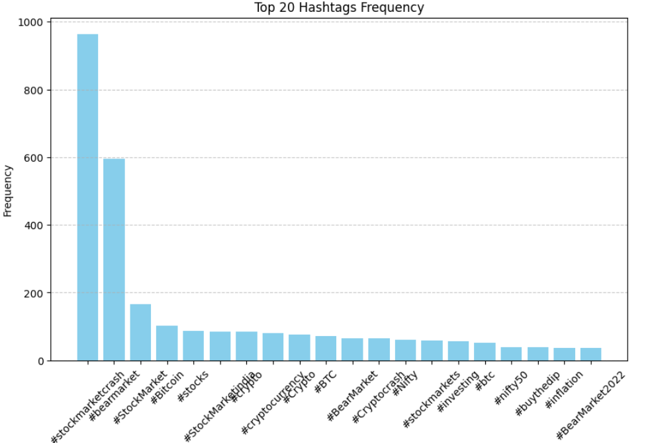
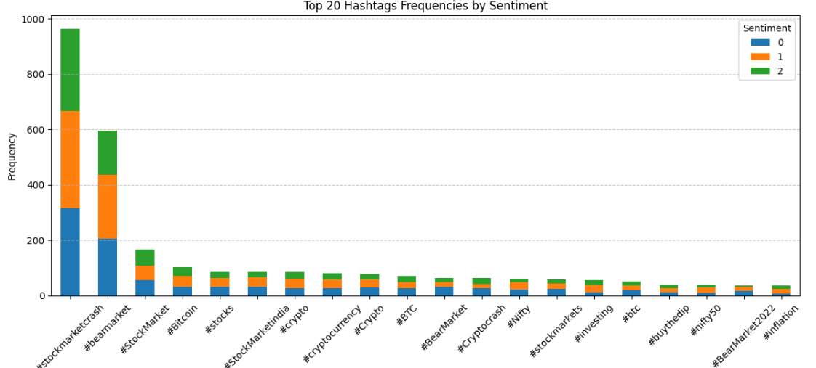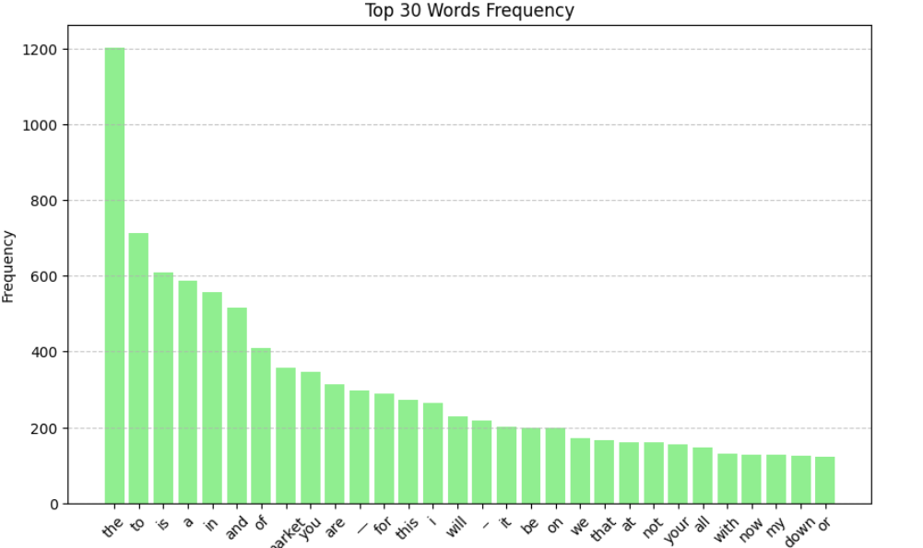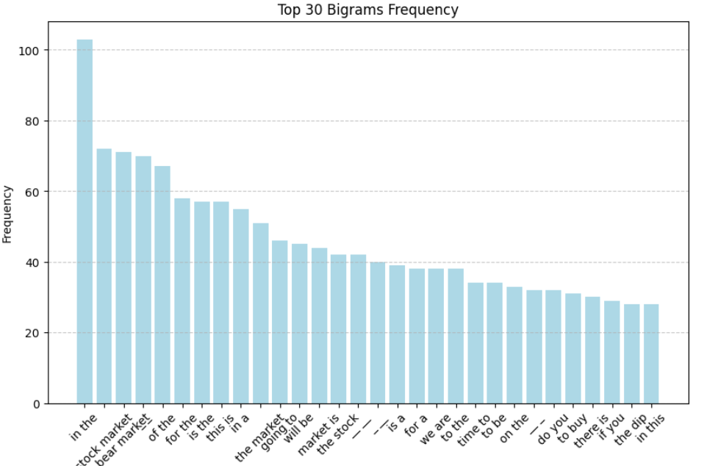
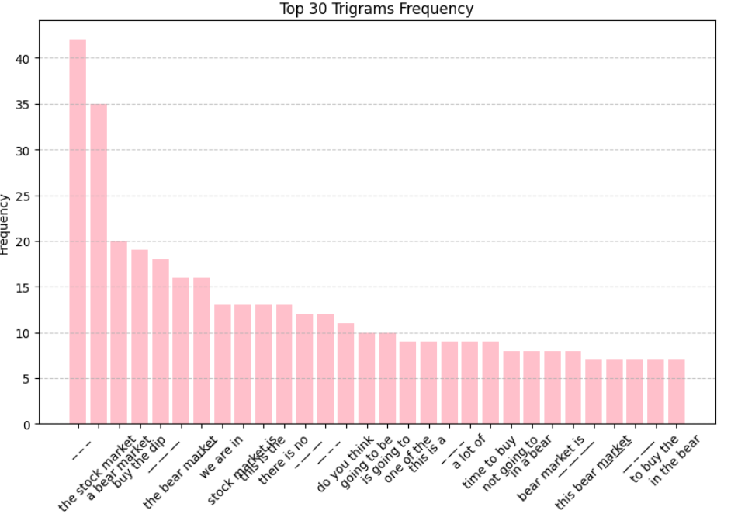
Lastly, we also found that neutral comments tend to have lower text length from the plot graph we made and over 6000 words only appeared once in all comments.
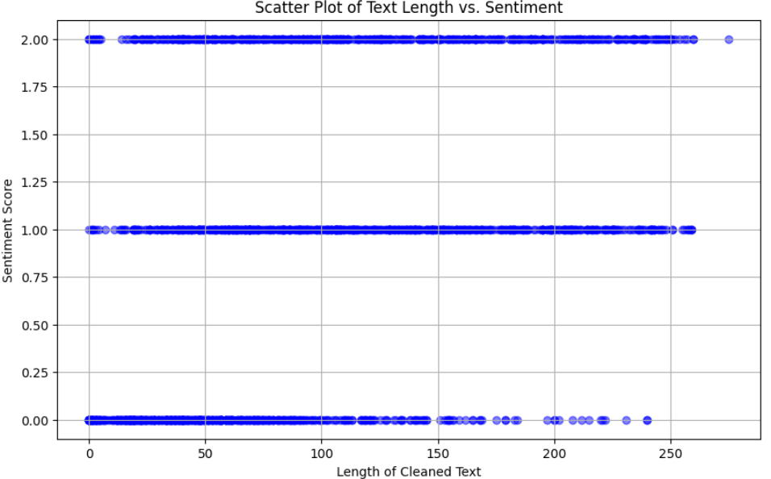

Conclusion
This project set out to build a system that can distinguish whether a tweet about the 2022 stock market crash is positive, neutral, or negative. Using PySpark and Spark NLP, we started with a simple baseline model and then tried a range of more advanced approaches to see how much we could improve the results.
Our baseline model, which combined TF-IDF features with Logistic Regression, reached an accuracy of about 54.7%. This gave us a solid starting point, but we knew there was room for improvement. When we tested other models, the best single model turned out to be GloVe + Logistic Regression, which achieved around 60.8% accuracy. This shows that using richer word representations, which capture more context and meaning, can make a real difference compared to just counting word frequencies.
We also tried tuning Random Forest, Naïve Bayes and Decision Tree models, but their performance stayed roughly between 51% and 54%. This suggests that with our current features, these models were already close to their limit on this dataset.
The biggest gain came from combining models. Our hard voting ensemble, which takes the majority prediction from the tuned Random Forest, Naïve Bayes and Decision Tree models, jumped to around 70% accuracy. The stacking ensemble also beat the baseline, reaching about 62.7%, though it didn't perform quite as well as the voting approach.
Looking at the data visually helped us understand what the models were working with. The tweets were fairly evenly split across the three sentiment classes. Word clouds and frequency charts showed clear patterns: neutral tweets often included words like "think" and "dip", while positive and negative tweets had their own distinctive language, such as "good" and "crash". We also noticed that neutral comments tended to be shorter than the others.

